VIT Bhopal University
Digital Literacy Project Portfolio
Course Code: CSE0001
Academic Year: 2025-2026
Submitted By: Ayush Tripathy
Registration Number: 25BEC10096
Branch: [ECE]
Year: 1st Year
Date: March 31, 2026

Introduction
I have been selected as a Student Digital Ambassador at VIT Bhopal University. My role is to help my peers navigate the digital world—from creating professional online profiles to communicating safely and responsibly. This project is a Digital Literacy Portfolio that demonstrates my skills across five different modules. I have organized all my work in a GitHub repository, and this report documents my practical learning, observations, and reflections on each task.

Task 1 - Digital Literacy Infographic
Description: For the first task, I designed a one-page visual infographic using Canva. The goal was to create a resource that explains the core pillars of digital literacy to my batchmates, including tips for safe internet use and professional behavior online.
Reflection: Designing this infographic taught me how to present complex information in a simple, visual way. I learned that using icons and short bullet points is more effective than long paragraphs for spreading awareness. The most interesting part was choosing a layout that makes the information easy to read at a single glance.

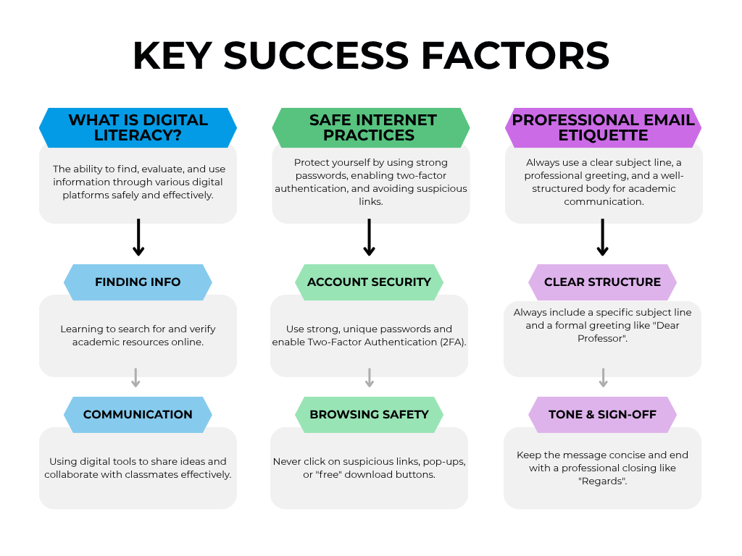

Task 2 - Student Digital Portfolio
Description: In this module, I established my professional digital presence by setting up accounts on GitHub and LinkedIn. On GitHub, I created a personalized profile README that highlights my branch (ECE), my current skills, and my interest in technical innovation. On LinkedIn, I updated my professional headline and added VIT Bhopal University to my education section.
Purpose and Future Plans: The primary purpose of choosing these platforms is their importance in the professional world. LinkedIn is the gold standard for networking with industry experts and discovering internship opportunities, while GitHub serves as a live portfolio to showcase my coding projects and technical contributions. My future plan is to consistently update these profiles over the next four years. I intend to document every major academic project on GitHub and use LinkedIn to connect with recruiters and stay updated on the latest trends in the electronics and communication industry. This will help me build a strong personal brand by the time I reach my final year placements.
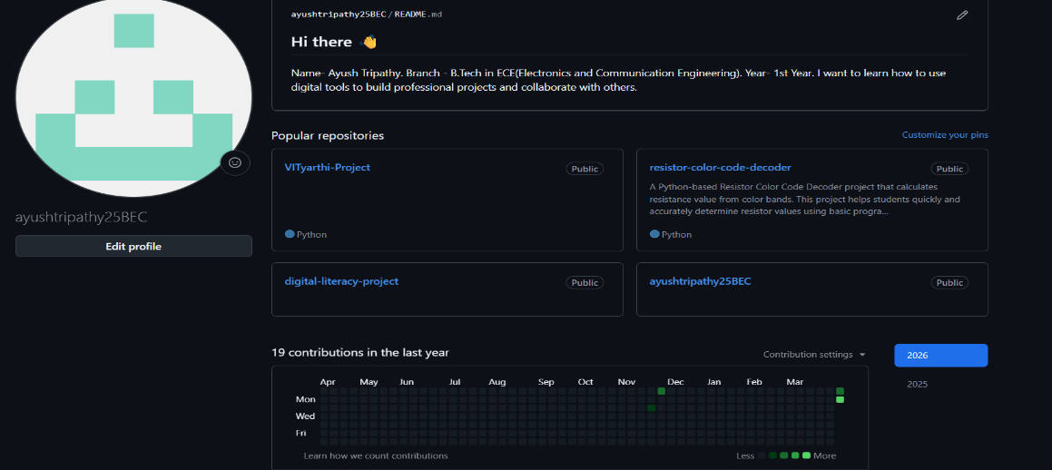

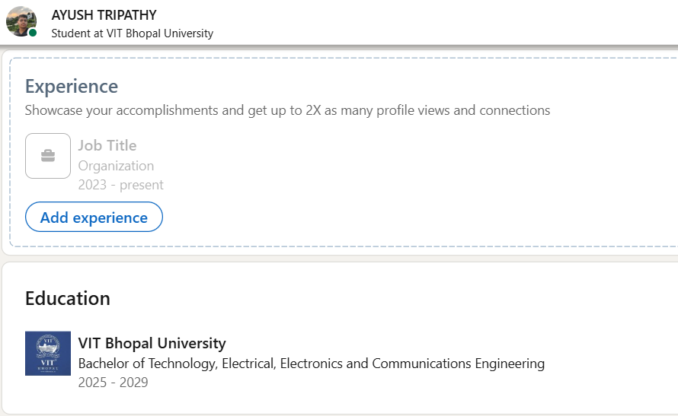
Task 3 - Coding & Collaboration Platforms
Platforms Used: For this task, I utilized two different digital platforms to enhance my technical and organizational skills. First, I used HackerRank, a competitive programming site, to practice problem-solving. Second, I used Google Forms from the Google Workspace suite to create a tool for digital data collection and collaboration.
What I Built/Practiced: On HackerRank, I practiced fundamental programming logic by solving beginner-level challenges. I successfully completed a coding task and earned a badge, which demonstrates my ability to write basic algorithms and handle standard input/output. For the collaboration part, I built a Digital Literacy Awareness Quiz using Google Forms. This quiz consists of five structured questions, including multiple-choice and short-answer formats, designed to test a user's knowledge of online safety, phishing, and digital tools. I also configured the form to collect responses in an organized manner, which is a crucial skill for conducting surveys or managing group projects in an academic setting.
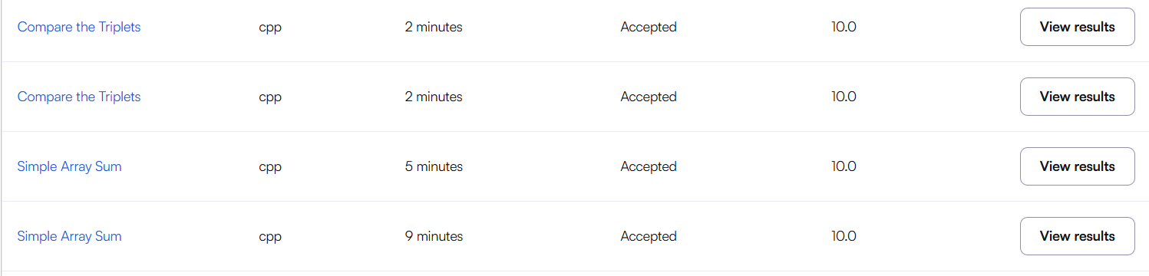
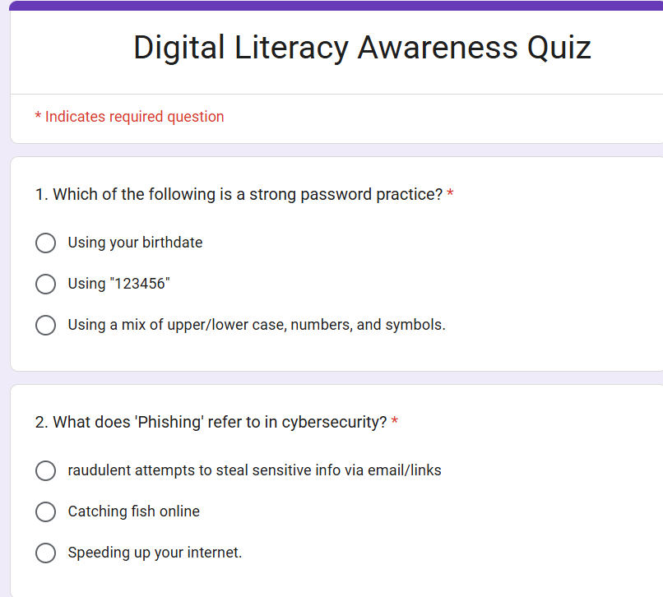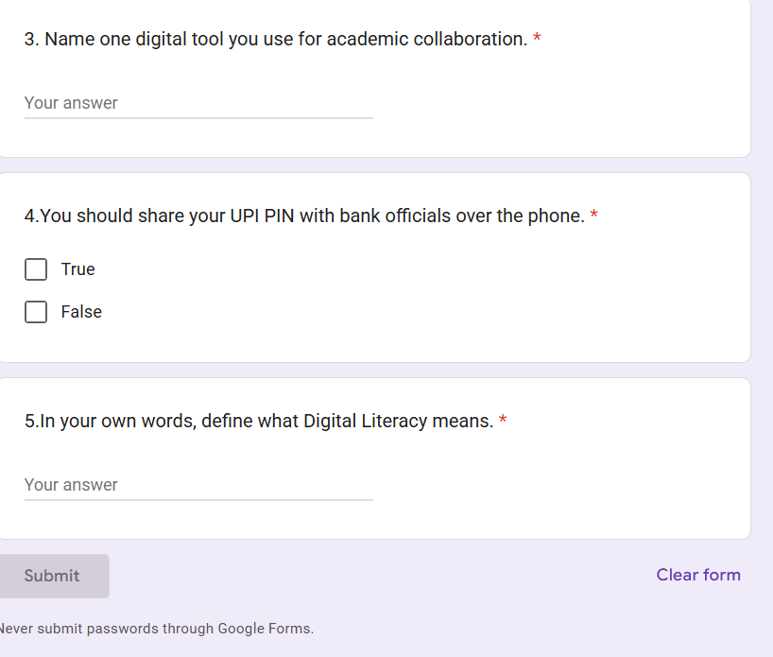
Task 4 - Professional Email & Etiquette
Communication Scenario: In this task, I explored the importance of formal digital communication. I drafted two professional emails: one addressed to a professor requesting an extension for a project due to technical issues, and another to a hiring manager at Synopsys inquiring about an internship opportunity. Additionally, I created a social media checklist with 5 Do’s and 5 Don’ts to maintain a clean and professional digital footprint as a college student.
Key Learnings: I learned that a professional email must always have a clear Subject Line, a formal Salutation, and a concise Body. A common communication failure occurs when students use informal "slang" or forget to mention their details (like Reg No.), which leads to delays or no response from faculty. My key learning is that "Digital Etiquette" is as important as technical skills. Being respectful, proofreading for errors, and following a structured format ensures that our messages are taken seriously in a professional environment.
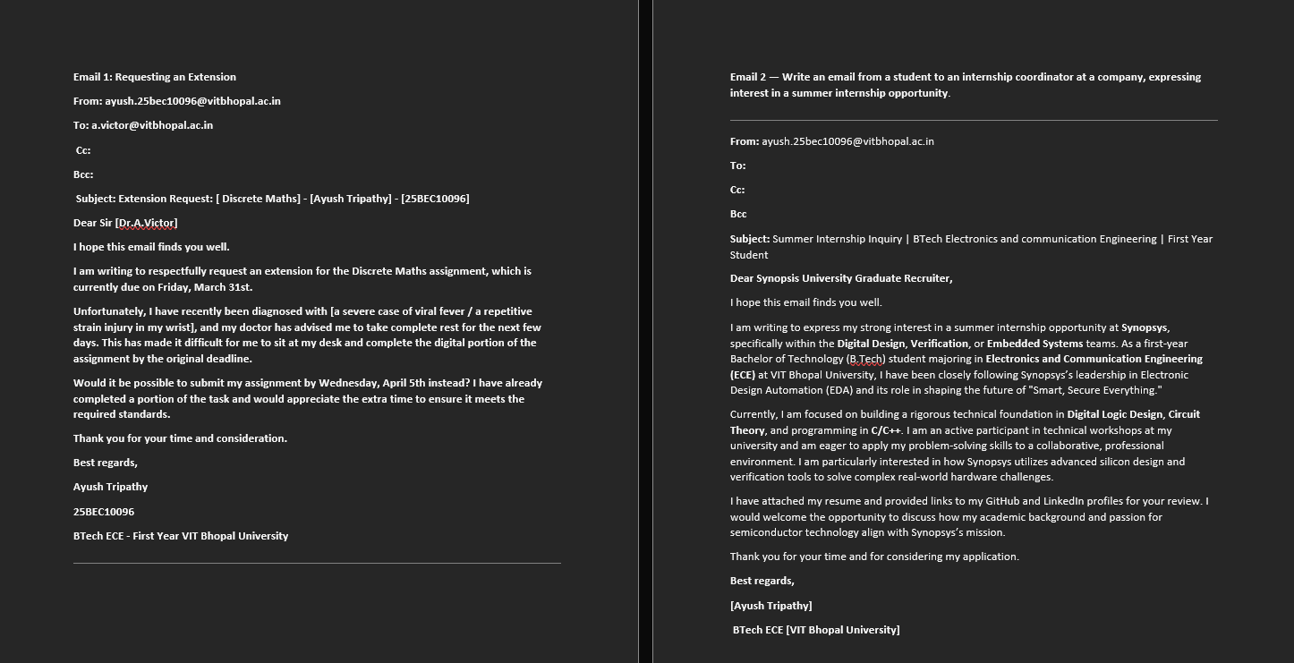
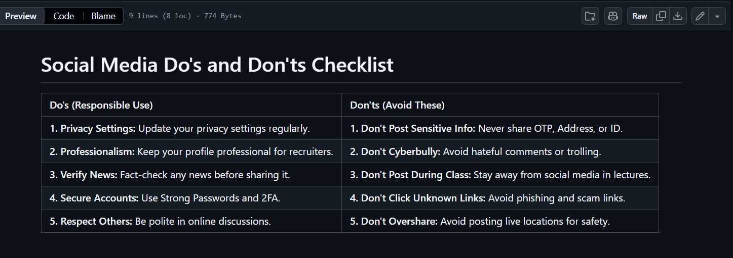
Task 5 - Cybercrime Awareness
Write-up: During this module, I researched a case study on UPI/Online Payment Fraud, specifically focusing on how scammers use fake QR codes to steal money. I documented the process of how these frauds occur and created a "Stay Safe Online" prevention checklist with 8 actionable safety tips, including information on how to report crimes through the National Cyber Crime Portal (1930).
Key Takeaways: What surprised me most was how easily people are tricked by "Receive Money" scams; many users do not realize that a UPI PIN is only required for sending money, not receiving it. This lack of awareness is what fraudsters exploit. The one habit I will definitely change is enabling Two-Factor Authentication (2FA) on all my digital accounts. I have also decided to always cross-verify the sender’s details before clicking on any payment links or scanning unknown QR codes to ensure my financial safety.
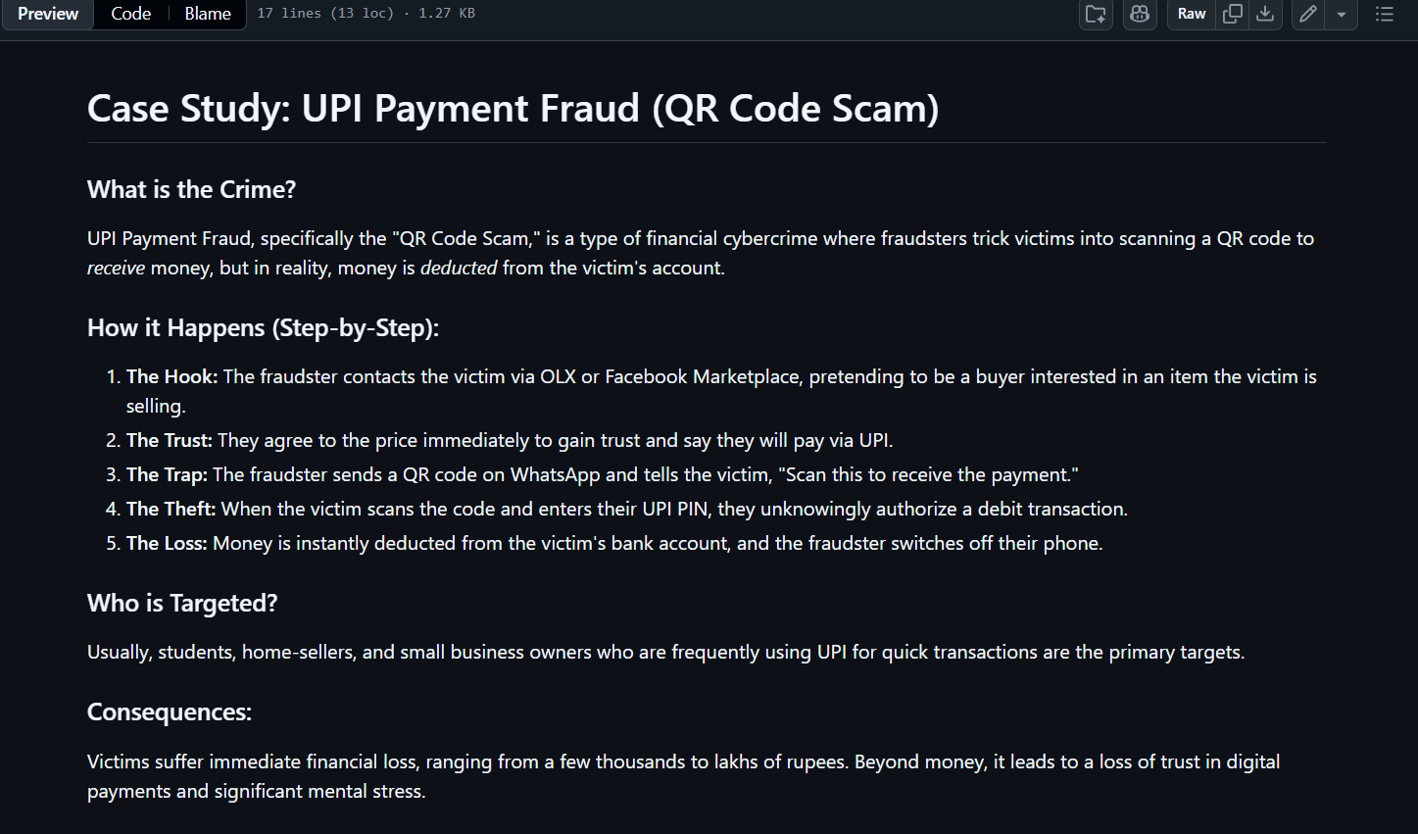
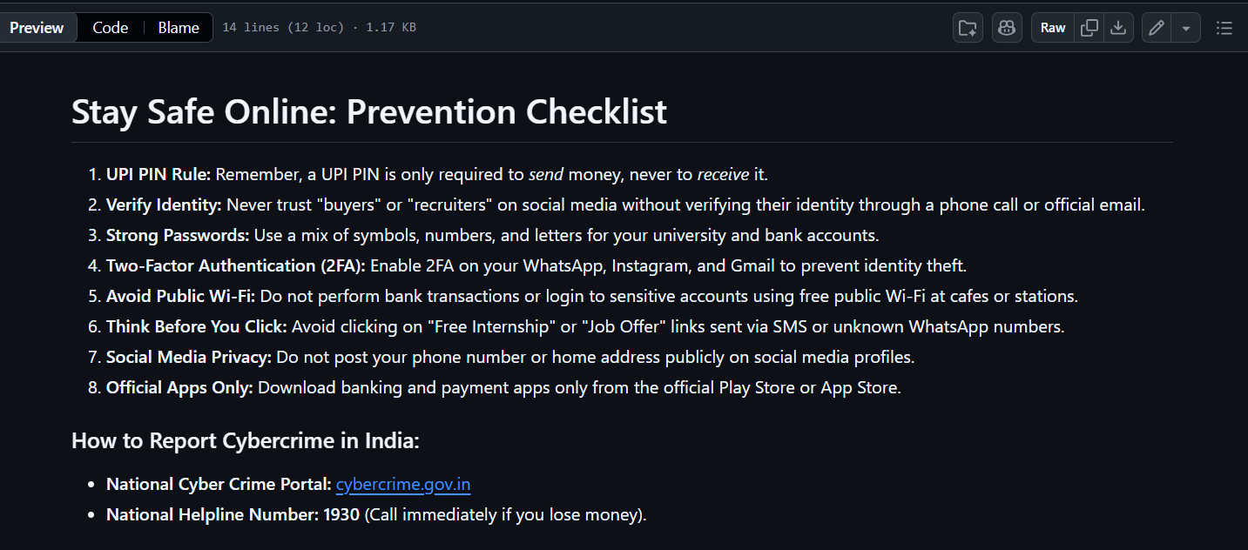
Conclusion & References
Conclusion: Completing this project has been a great learning experience. It has not only improved my technical skills like using GitHub and Canva but also made me more aware of my digital footprint and online safety. As a Digital Ambassador, I am now better equipped to help others stay safe and professional in the digital space.
References: 1. GitHub: www.github.com
2. LinkedIn: www.linkedin.com
3. Canva: www.canva.com
4. HackerRank: www.hackerrank.com
5. National Cyber Crime Portal: www.cybercrime.gov.in

